Contents

I Install Visual Studio 2017 2

Step 1 – Site Link 2

Step 2 – Download 2

Step 3- License agreement-SignUp 2

Step 4 - Select workloads 3

Step 5- INSTALL 4

Step 6- Launch 4

II Working with C# in Visual studio 2017 5

Create a simple application 5

Step 1: Create the project 5

Step 2- Select type of Project 6

Step 3- ToolBox (Elements on the Form) 8

Step 4- Add buttons and more elements to form 9

Editors and Designers 15

Graphical User Interface Designer: 15

Code Editor: 16

Properties window 16

Step 5- Adding action to Button click 17

Step 6- Save 19

Step 7-Executing program 19

Build and Debug Tools 21

Debug menu 21

III Add another Form 22

IV Create Menu 24

Goto below link to see installation steps:

<https://docs.microsoft.com/en-us/visualstudio/install/install-visual-studio>

# I Install Visual Studio 2017

## Step 1 – Site Link

Goto <https://www.visualstudio.com/downloads/>

## Step 2 – Download

Select the Visual Studio **Community** 2017-Free download

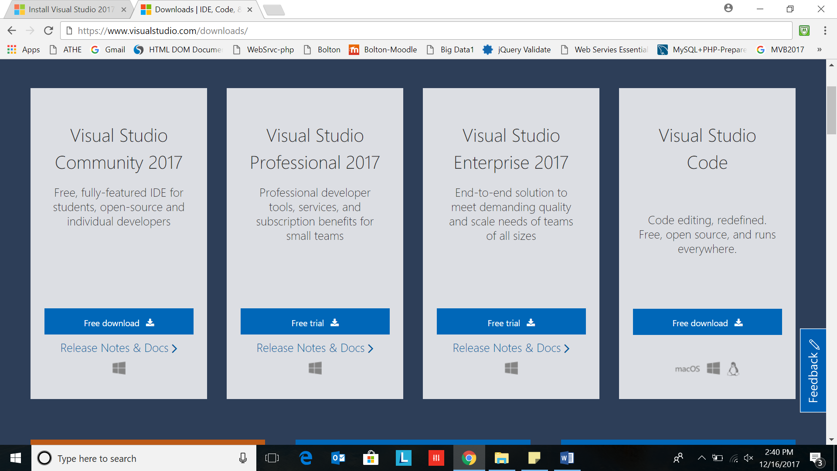

## Step 3- License agreement-SignUp

If you receive a User Account Control notice, click **Yes**.

Acknowledge the Microsoft [License Terms](https://www.visualstudio.com/license-terms/) and the Microsoft [Privacy Statement](https://go.microsoft.com/fwlink/?LinkID=824704). Click **Continue**.

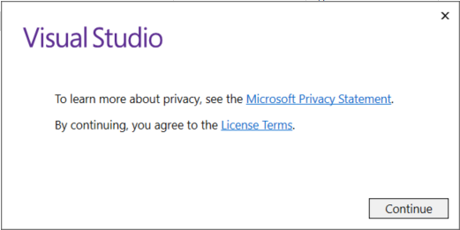

## Step 4 - Select workloads

Find the workload you want in the **Installing Visual Studio** screen. Choose

1. .NET desktop development workload.
2. Universal Windows Platform Development

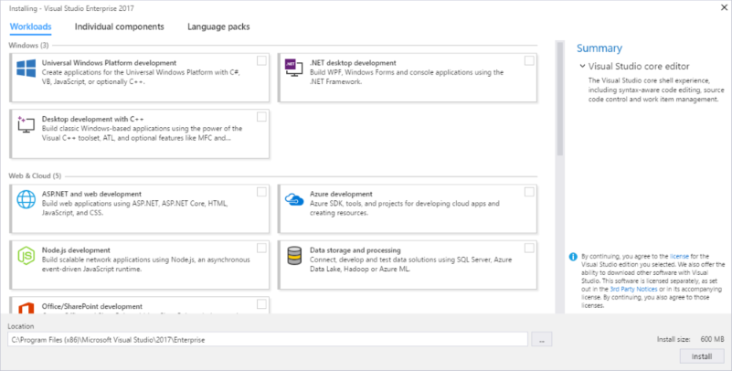

## Step 5- INSTALL

Click INSTALL

## Step 6- Launch

After the new workloads and components are installed, click **Launch**.

# II Working with C# in Visual studio 2017

[**https://msdn.microsoft.com/en-us/library/jj153219.aspx**](https://msdn.microsoft.com/en-us/library/jj153219.aspx)

**use below one:**

[**https://msdn.microsoft.com/en-us/library/dd492132.aspx**](https://msdn.microsoft.com/en-us/library/dd492132.aspx)

# Create a simple application

## Step 1: Create the project

When you create an application in Visual Studio, you first create a project and a solution.

##### **To create the project**

Create a new project. On the menu bar, choose **File**->**New->** **Project…**.

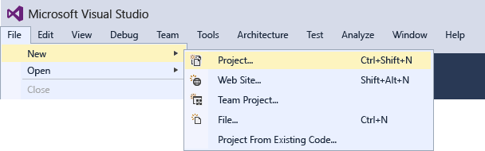



## Step 2- Select type of Project

1. **Visual C#**
2. **Windows Classic Desktop**
3. **Windows Forms App (.NET Framework).**
4. **Write name of your project in Name textbox (Don’t put spaces)**

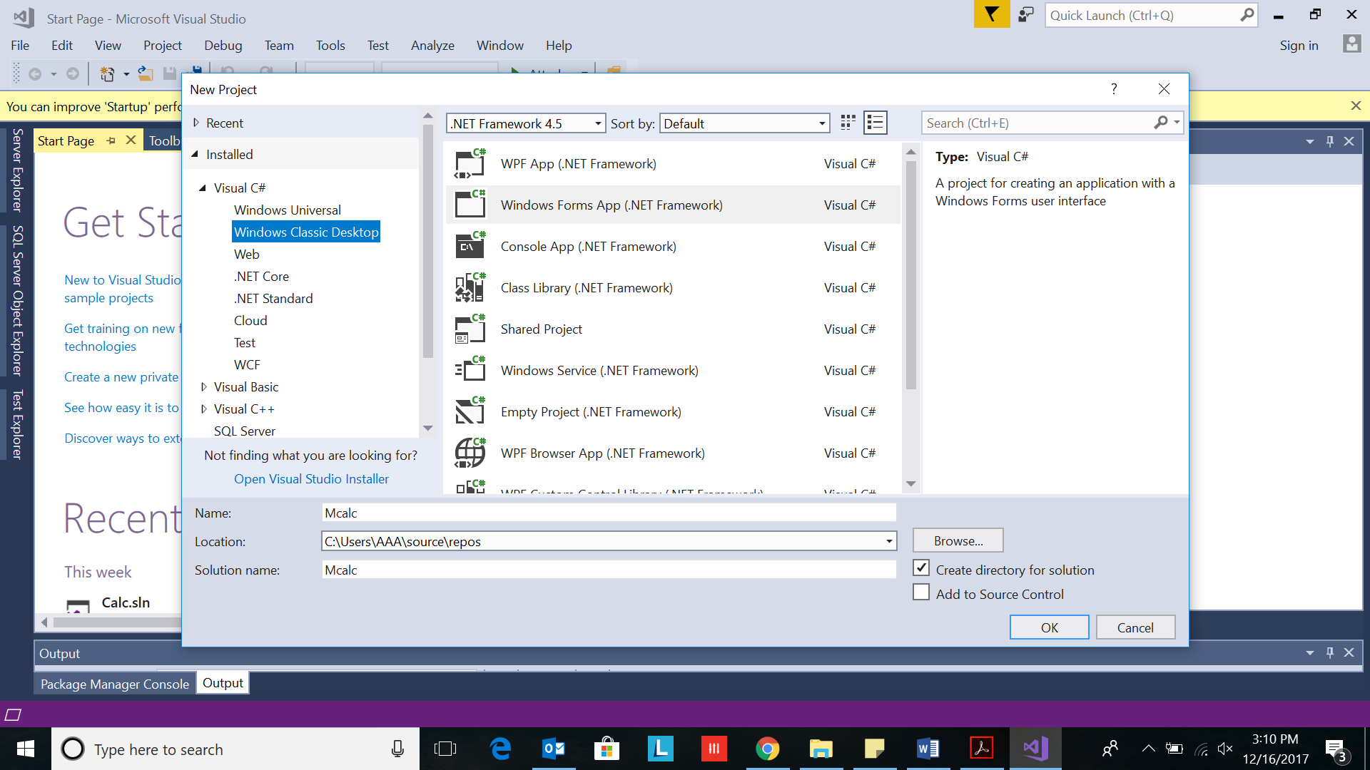

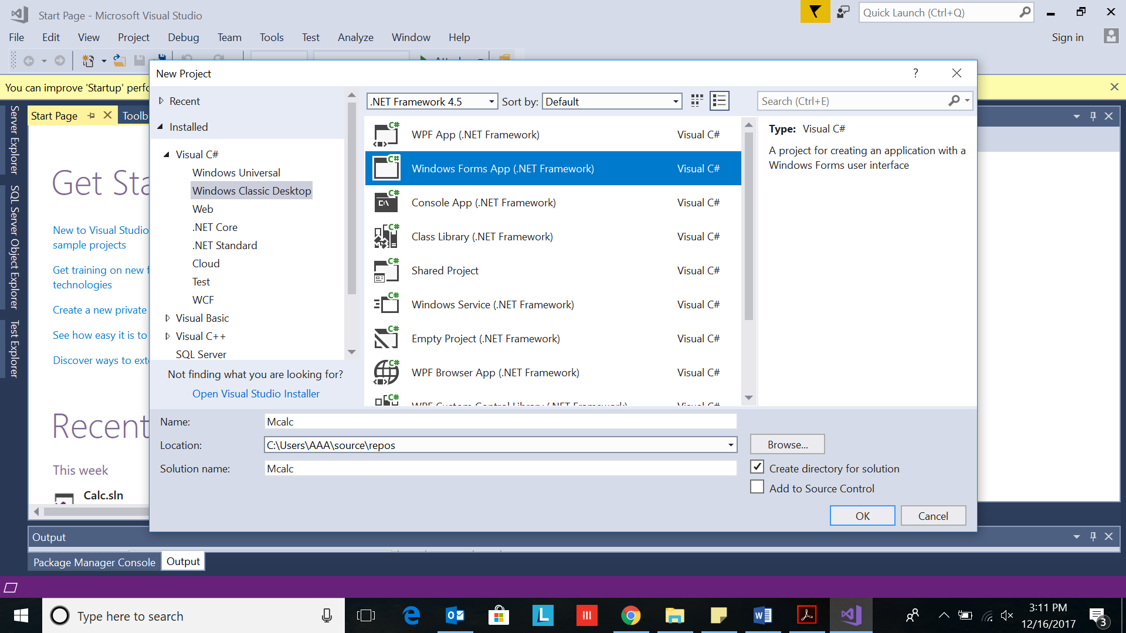

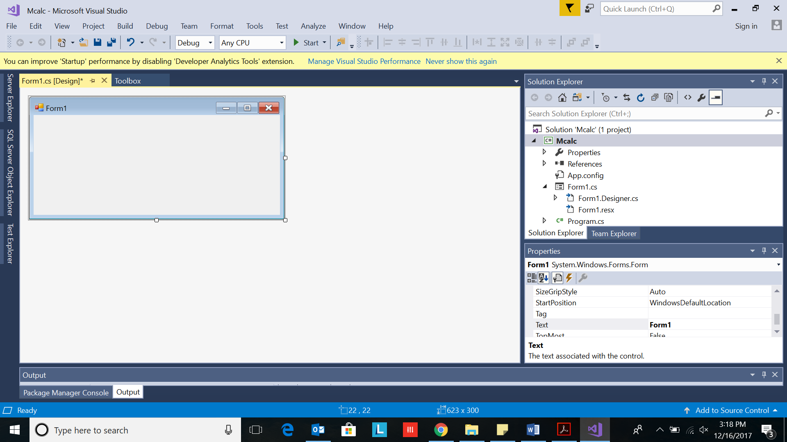

The interface contains three windows:

**Main window,** **Solution Explorer**, and the **Properties** window.

The illustration shows the following windows

(going clockwise from the upper-left corner):

* + **Main window**- Creating forms and editing code.

the window shows a form in the Form Editor.

At the top of the window, the **Start Page** tab and the **Form1.cs [Design]** tab appear.

* + **Solution Explorer window**

In this window, you can view and navigate to all items in your solution.

If you choose a file, the contents of the **Properties** window changes. If you open a code file (which ends in .cs in Visual C#), the code file or a designer for the code file appears.

A designer is a visual surface onto which you can add controls such as buttons and lists. For Visual Studio forms, the designer is called the Windows Forms Designer.

* + **Properties window** In this window, you can change the properties of items that you choose in the other windows. For example, if you choose Form1, you can change its title by setting the **Text** property, and you can change the background color by setting the **Backcolor** property.

## Step 3- ToolBox (Elements on the Form)

1. Goto View Tab on Top
2. Select ToolBox from its dropdown

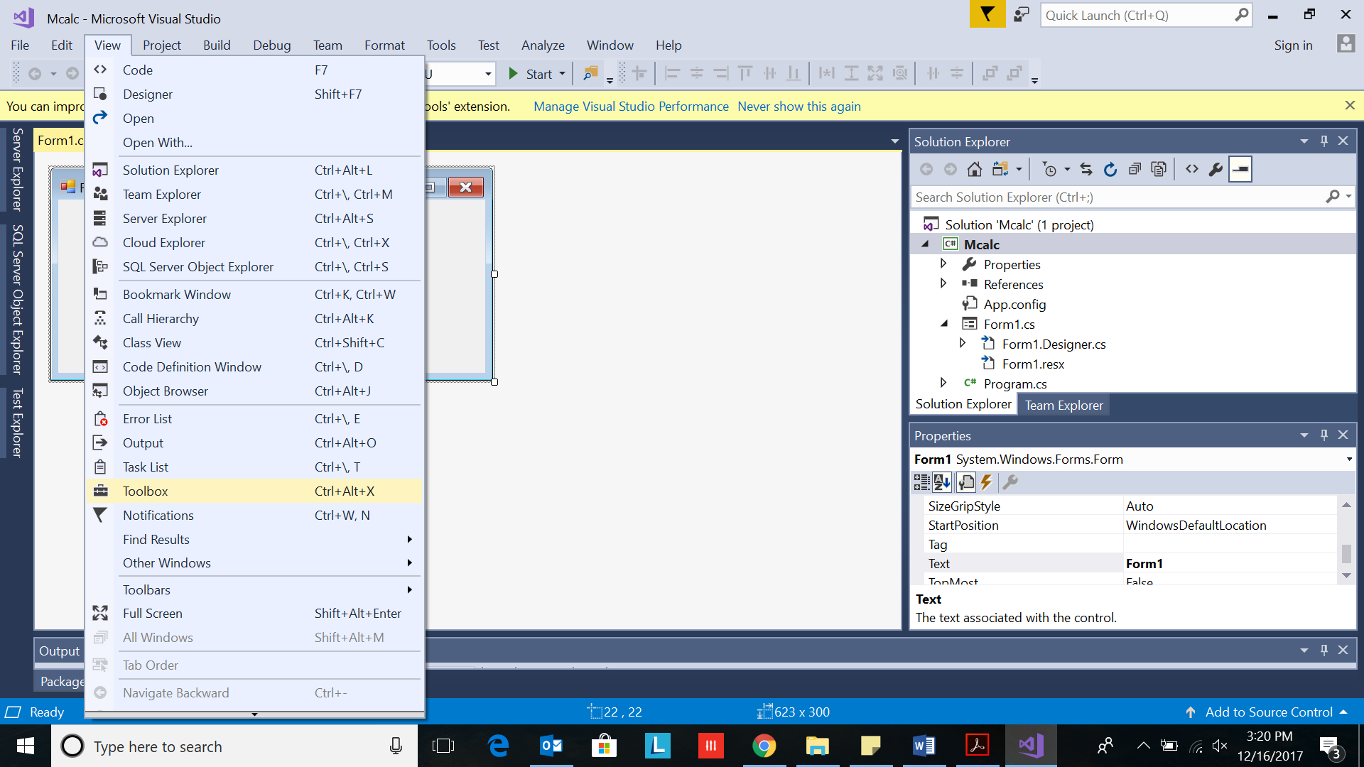

ToolBox Elements List appears

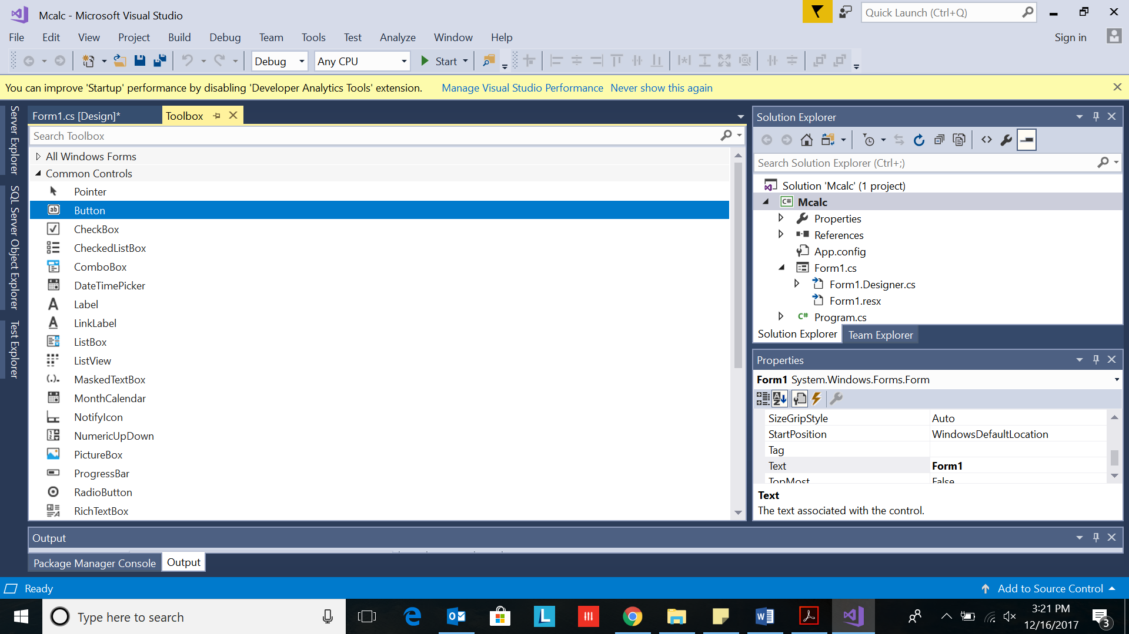

## Step 4- Add buttons and more elements to form

1. Select button.
2. Drag drop the button from toolbox to form
3. Select textbox, Button, Label elements
4. ListBox(Multiplication table form only)
5. Radio Button for Operation selection( for add,sub,multiply,divide form)

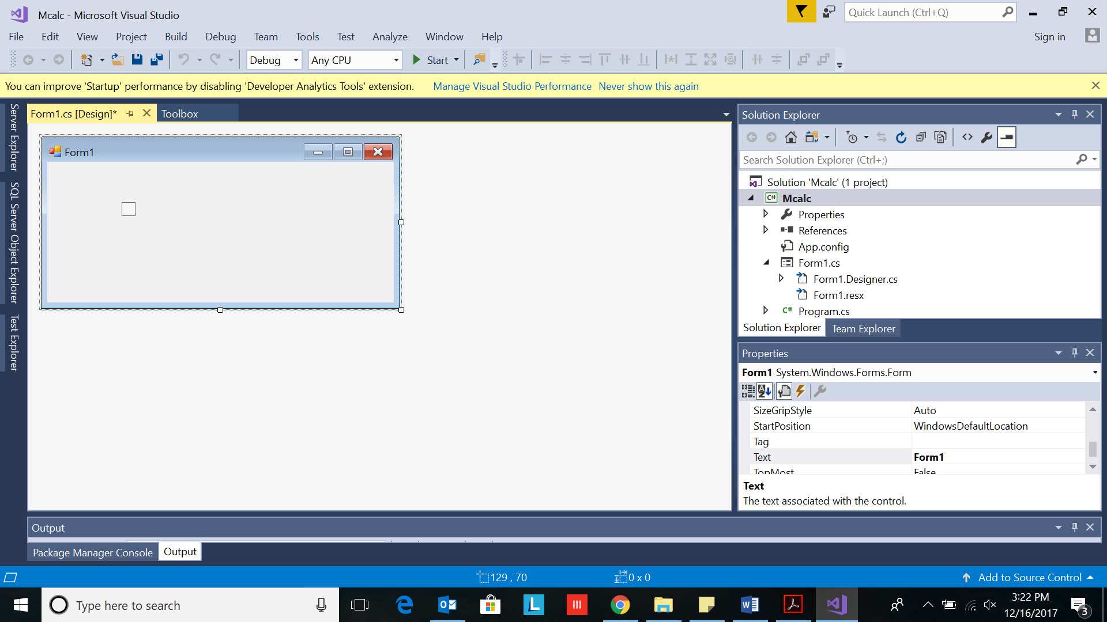

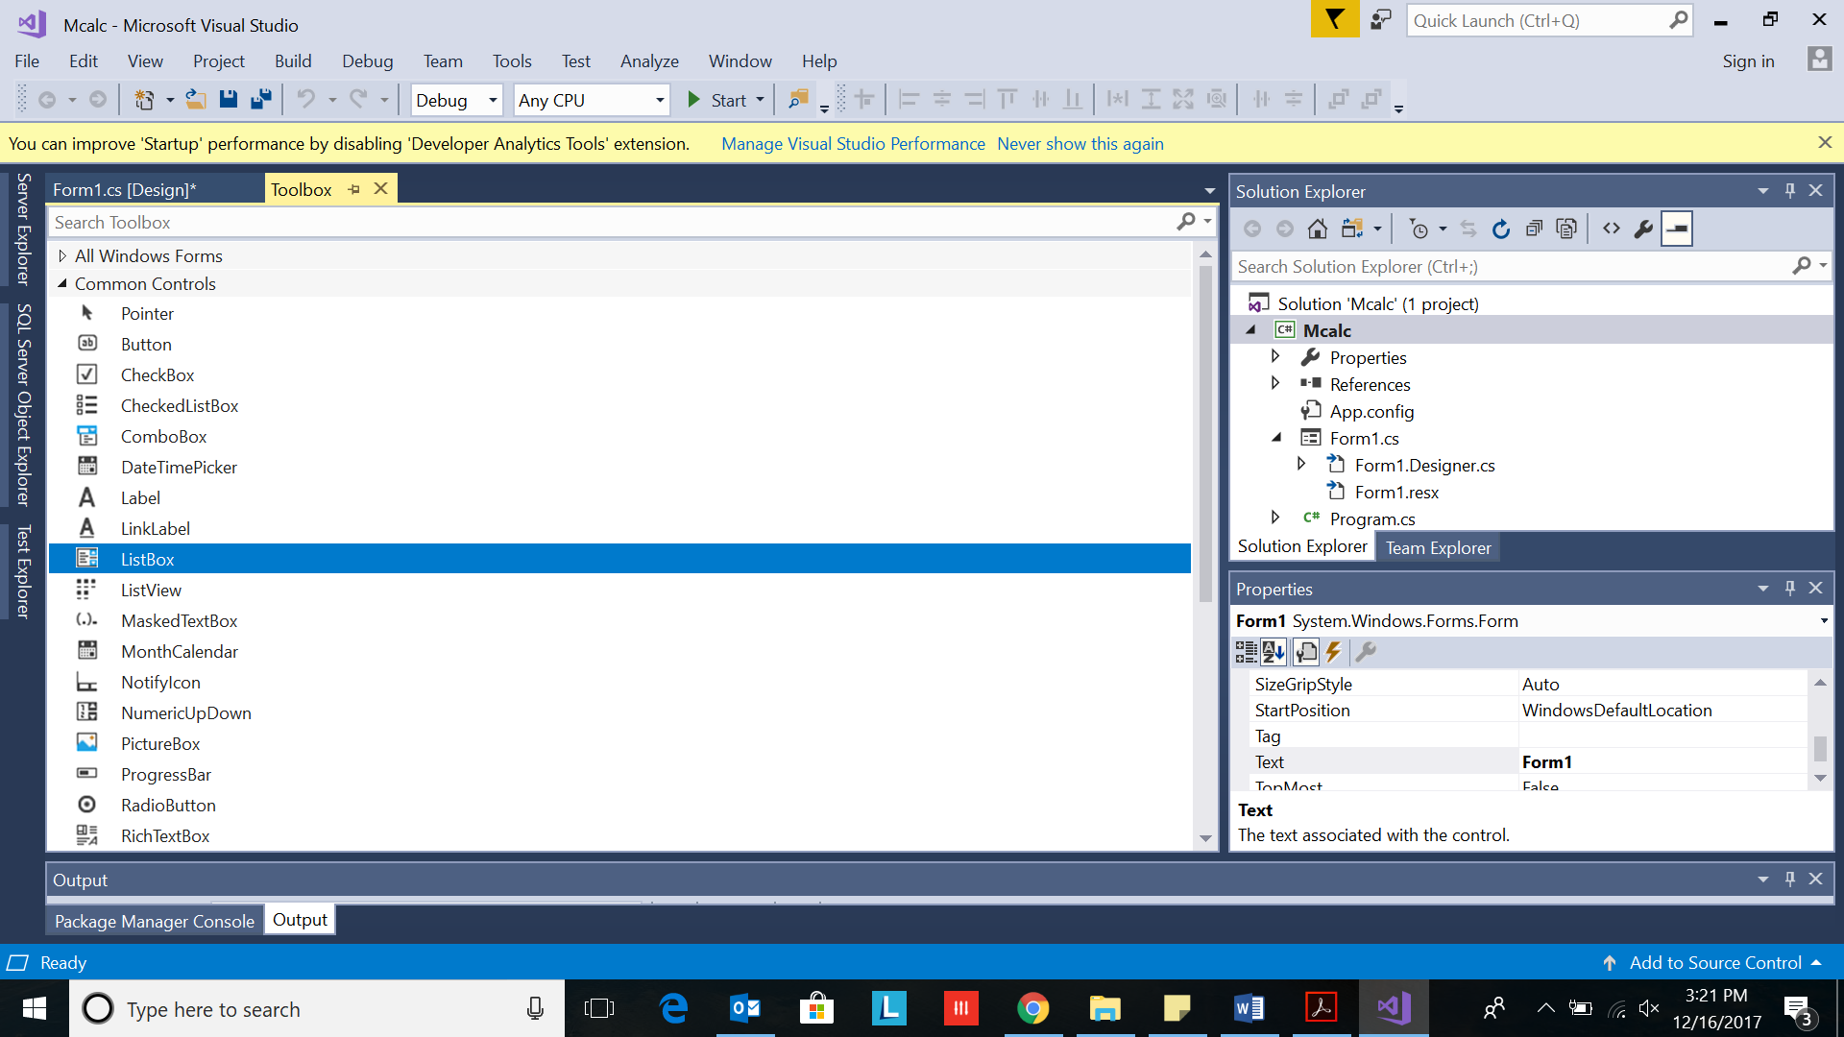

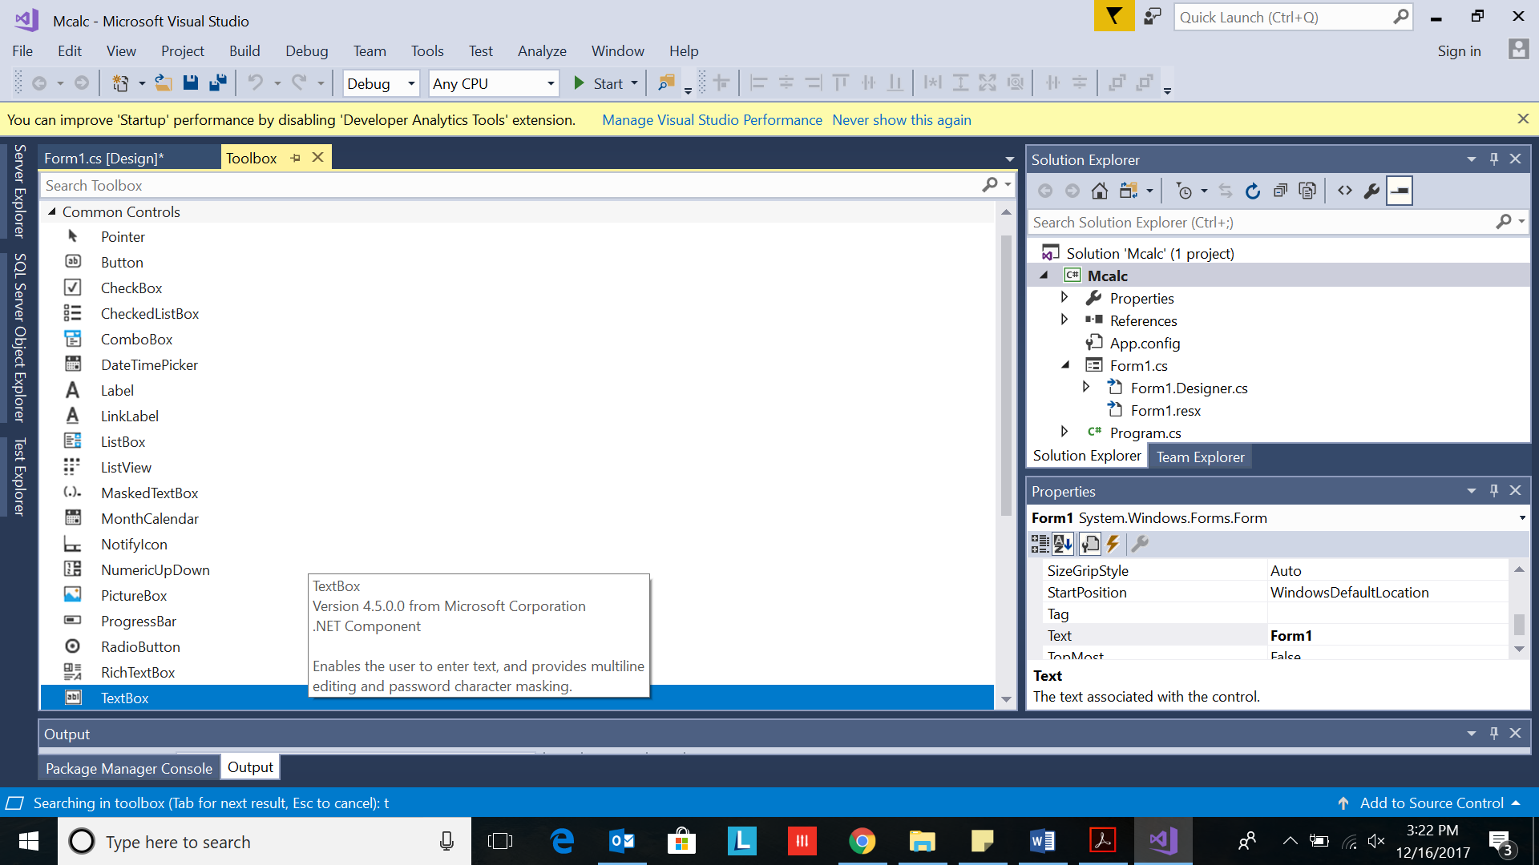

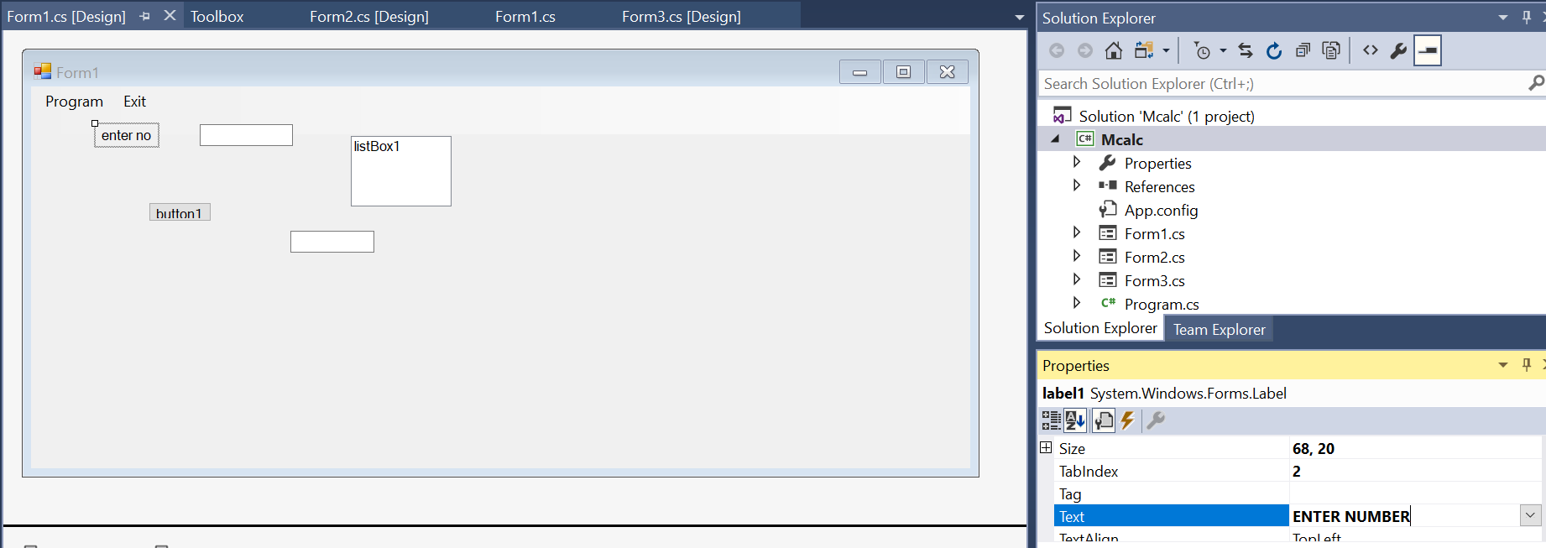

**Change the written text on label1**

Single click on Label1

goto Properties window on right

Goto text field and type ENTER NUMBER

Save(Control+S)

**Change the written text on BUTTON1**

Single click on BUTTON1

goto Properties window on right

Goto text field and type CHECK EVEN ODD

Save(Control+S)

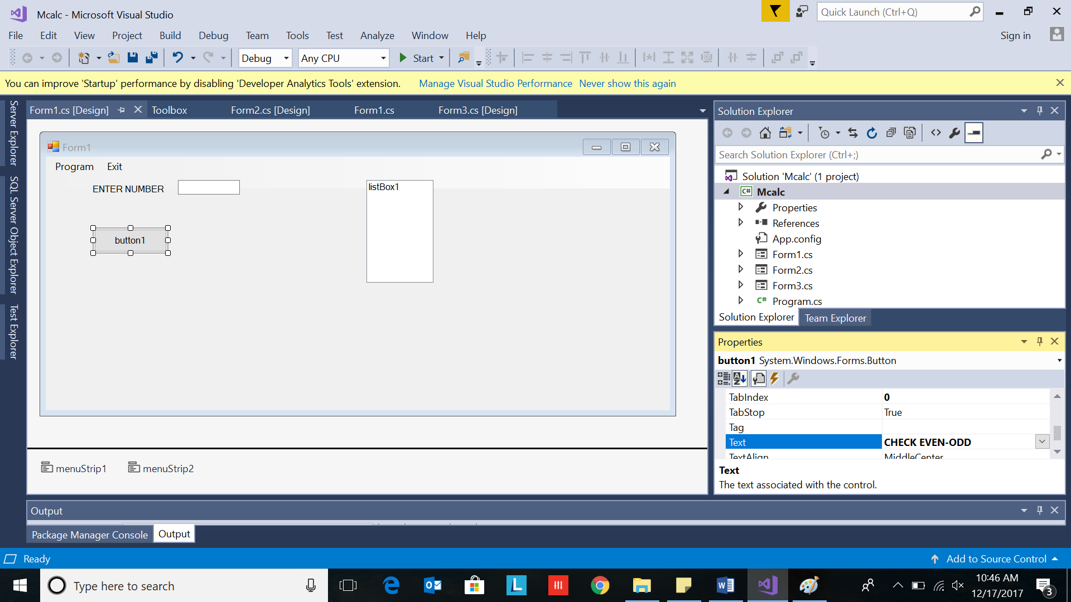

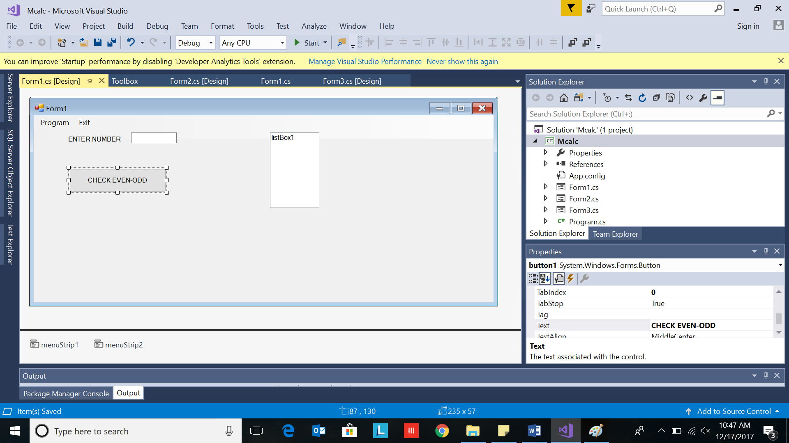

**Change the written text on Label2**

Single click on Label2

goto Properties window on right

Goto text field and keep it blank(empty)

Save(Control+S)

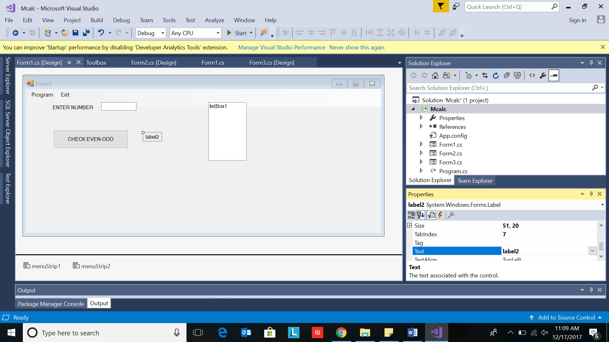

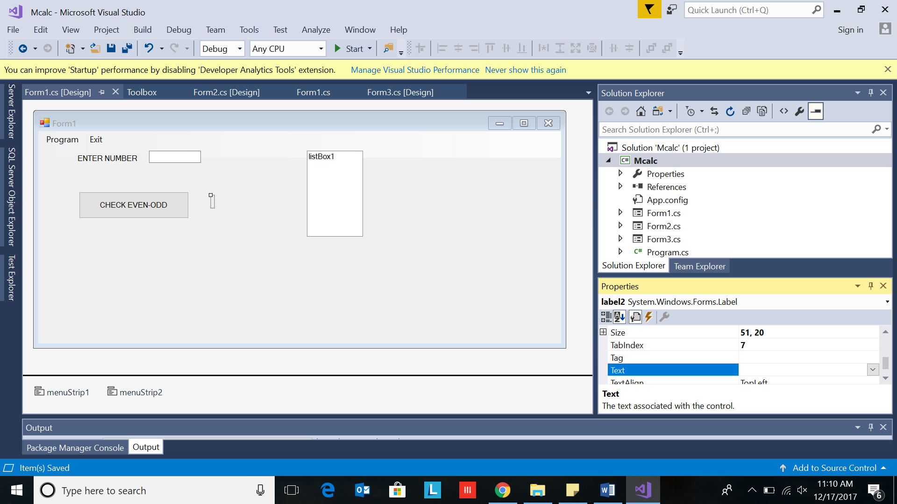

Toolbox

The Toolbox contains all the necessary controls, etc. you need to create your user interface.

See Figure below.

In order to use them in our user interface, we just drag and drop them to the “Form”, as shown below:

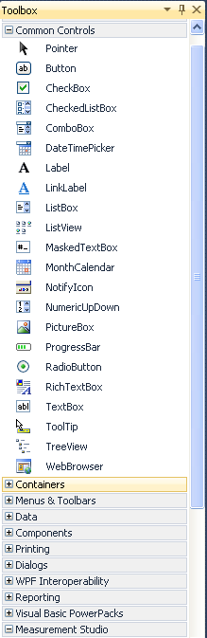 

## Editors and Designers

Visual Studio has different editors and design tools.

### Graphical User Interface Designer:



### Code Editor:



For Visual C#, the event handler should look like this:

private void Button_Click_1(object sender, RoutedEventArgs e)

{

}

For Visual C#, enter the following code:

if (RadioButton1.IsChecked == true)

{

MessageBox.Show("Hello.");

}

else

{

RadioButton2.IsChecked = true;

MessageBox.Show("Goodbye.");

}

Save the application.

### Properties window

Each control we have on our user interface has lots of Properties we can set.

This is done in the Properties window:



## Step 5- Adding action to Button click

Double the CHECK EVEN ODD Button.

It opens the code editor.

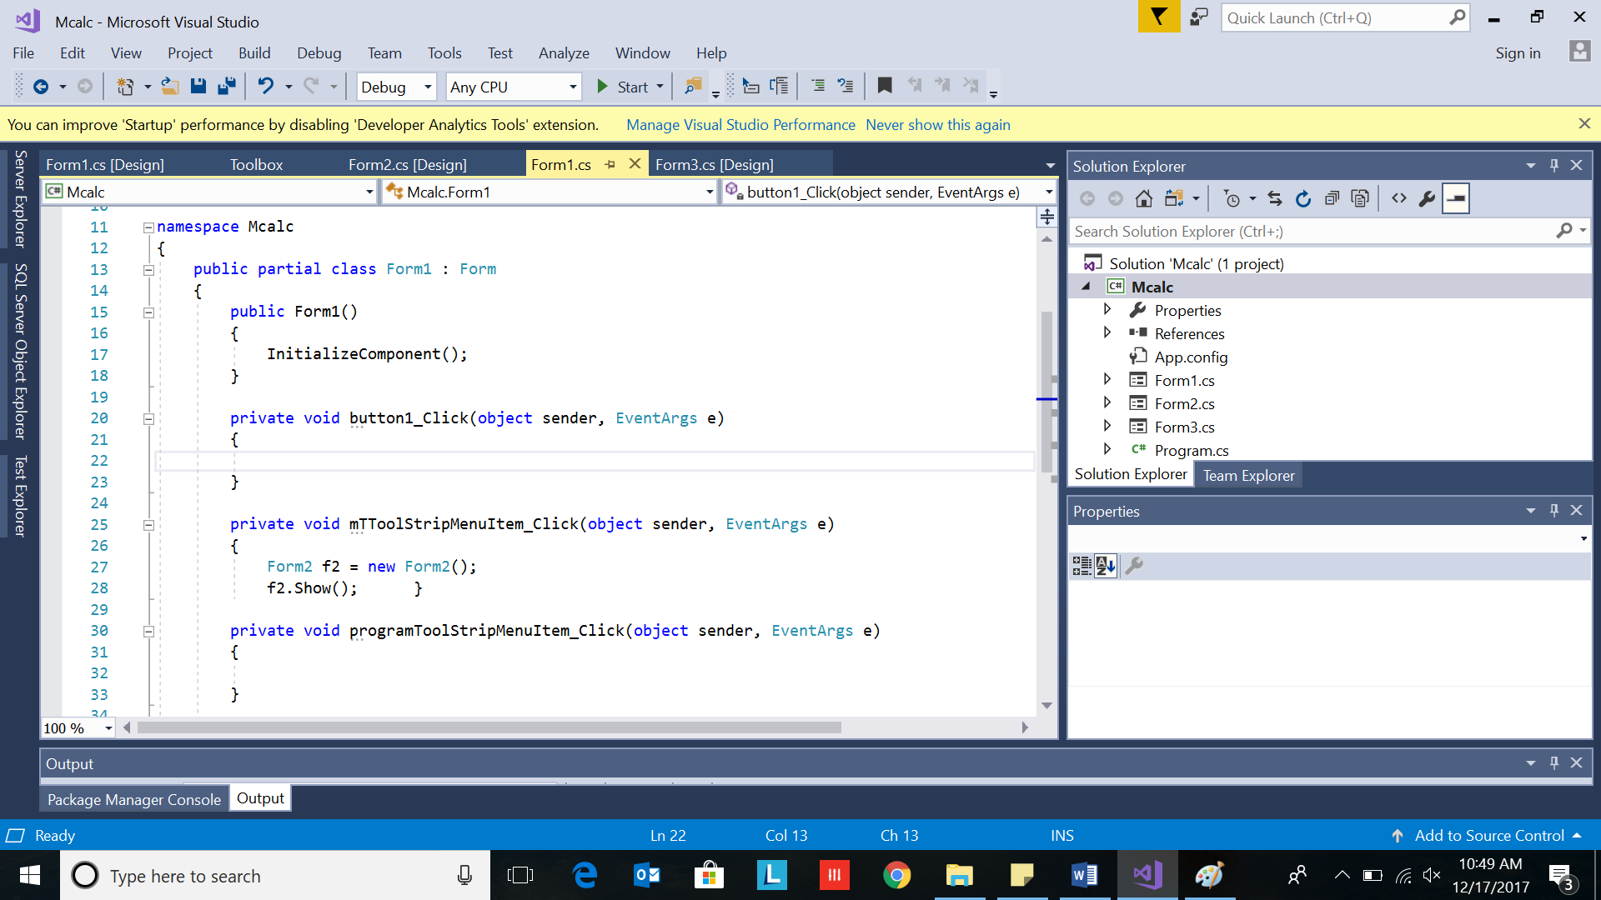

In the function, respective to click for the button

private void **button1_Click**(object sender, EventArgs e)

{

}

Add the code to handle the operation

int num;

num = Convert.ToInt32(textBox1.Text);

if (num % 2 == 0)

label2.Text = "Number is Even";

else

label2.Text = "Number is Odd";

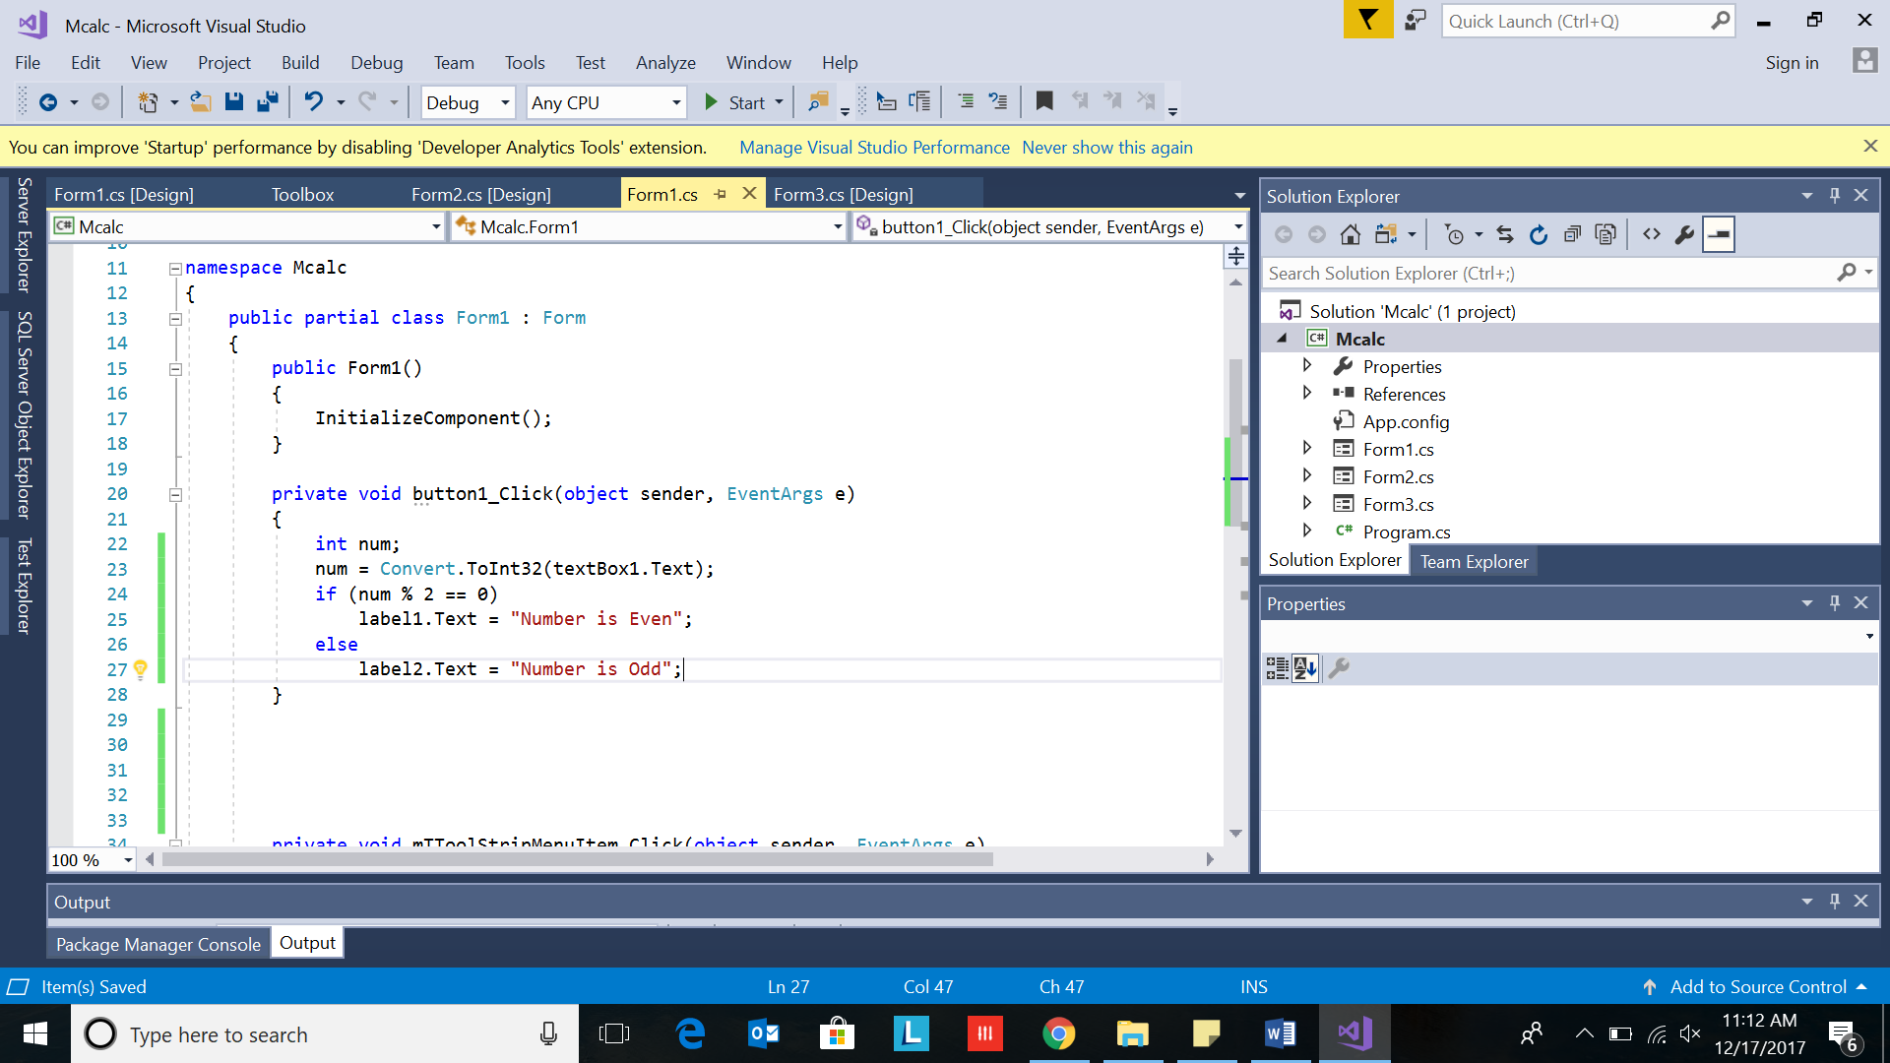

(Check the programs in the Programs folder on google drive )

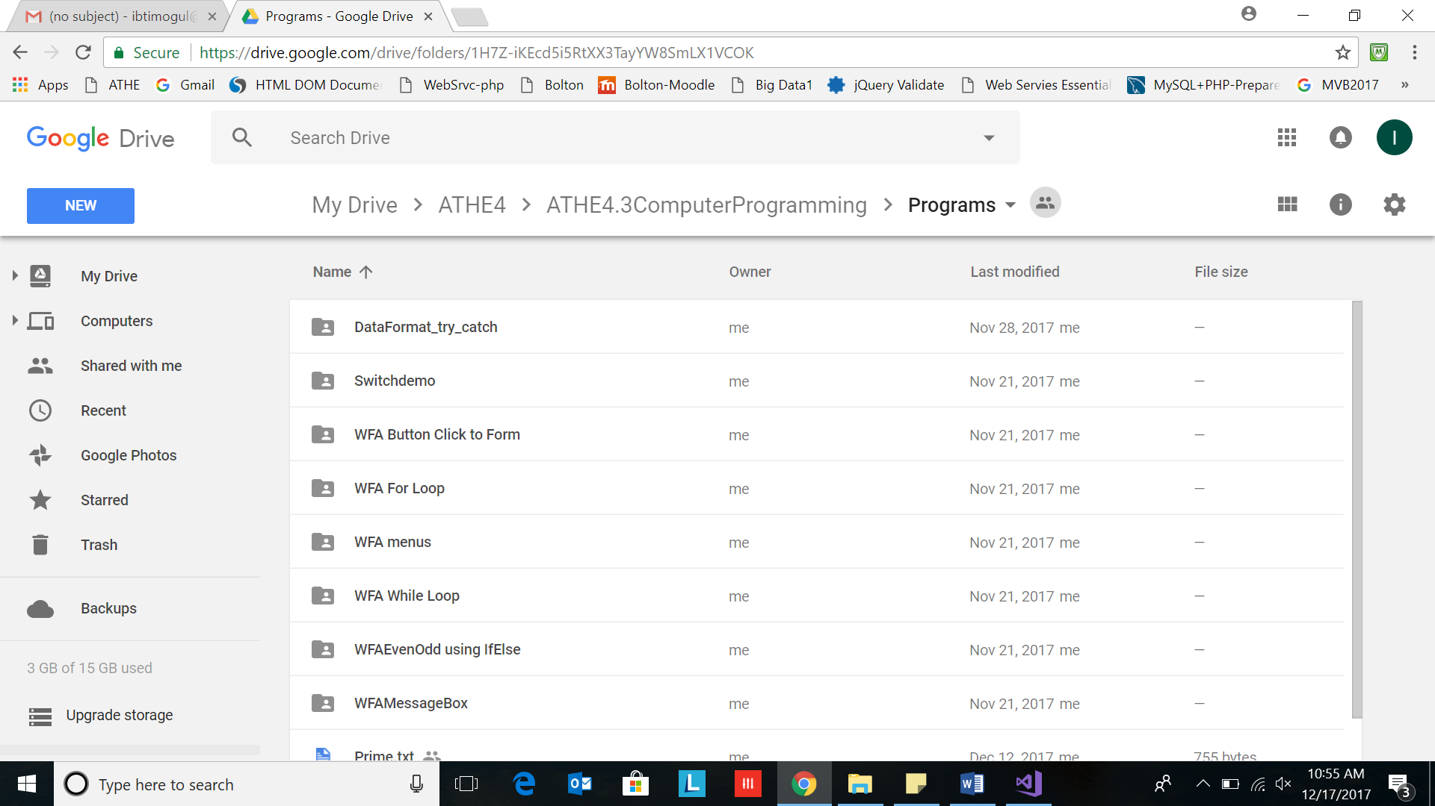

Referring Folders:

1. For MultiplicationTable - WFA While Loop
2. EvenOdd - WFAEvenOdd using IfElse
3. Factorial- WFA For Loop
4. Operations(+,-,*,/) - SwitchDemo
5. Menus on top and additional forms- WFA menus
6. Handling Data format errors- DataFormat_try_catch

## Step 6- Save

Control+S

## Step 7-Executing program

Click on Start button

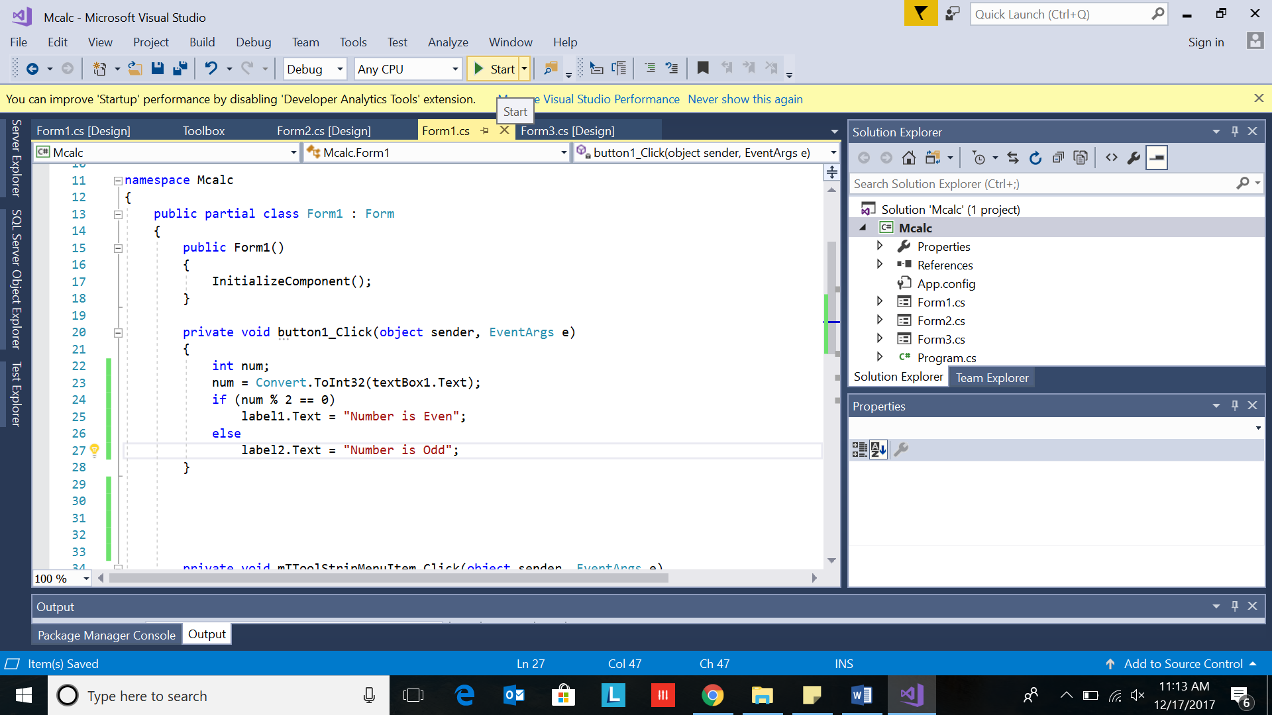

Form Appears

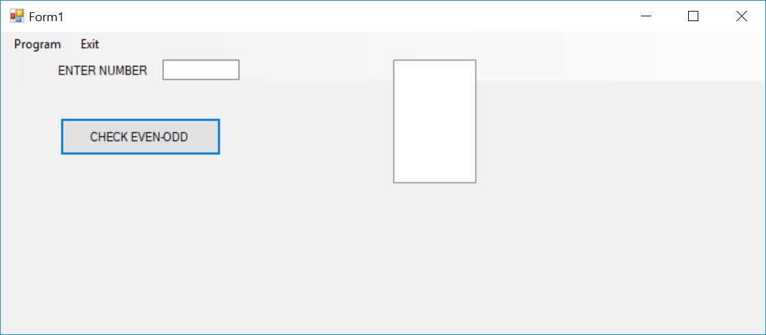

Type 4 in the textbox

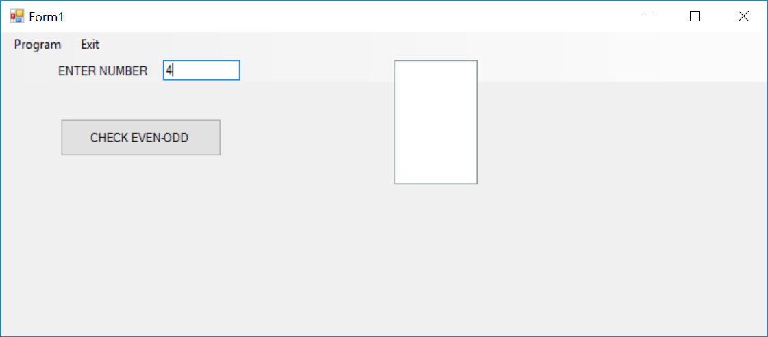

Answer appears in the label2(Number is even)

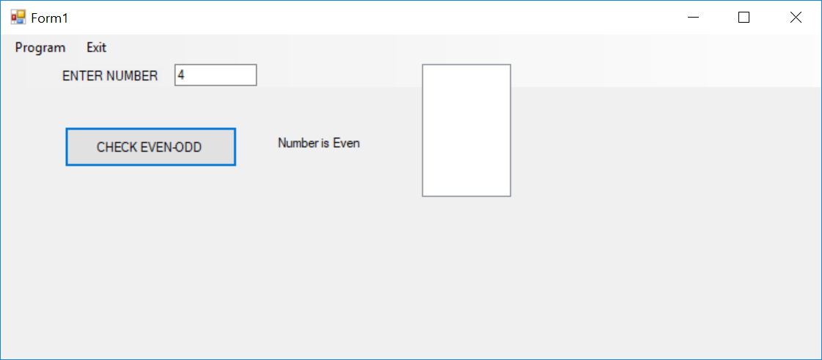

Note: Don’t keep listbox in evenodd

### Build and Debug Tools

In Visual Studio we have lots of Build and Debugging Tools.

**Build menu:**

Below we see the **Build** menu:



The most used tool is “**Build Solution**” (Shortcut Key: F6).

### Debug menu

Below we see the **Debug** menu:

The most used tool is “**Start Debugging**” (Shortcut Key: F5).

# III Add another Form

Select Project in Solution Explorer.

Right click it.

Select Add

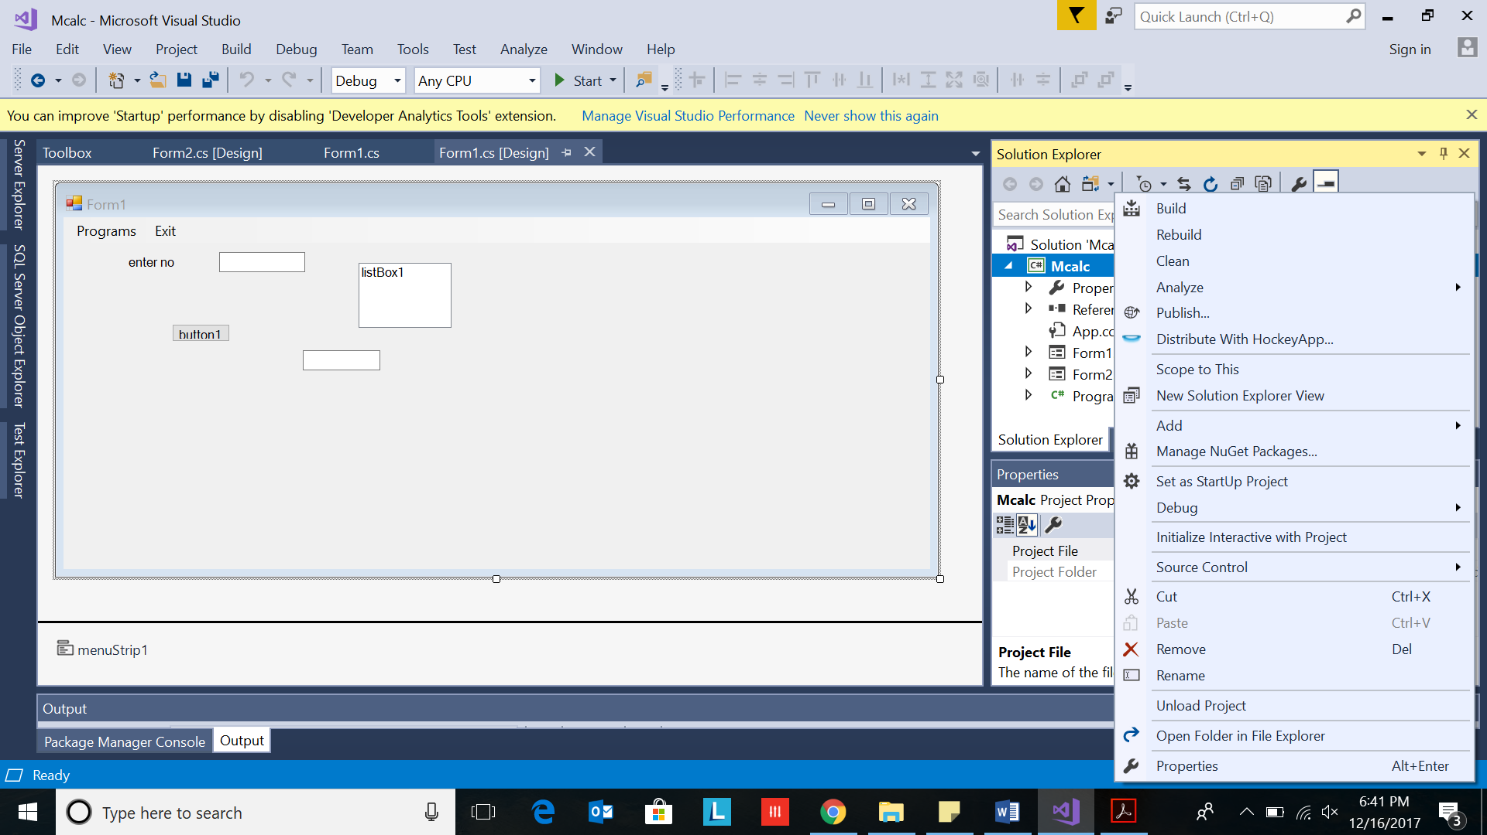

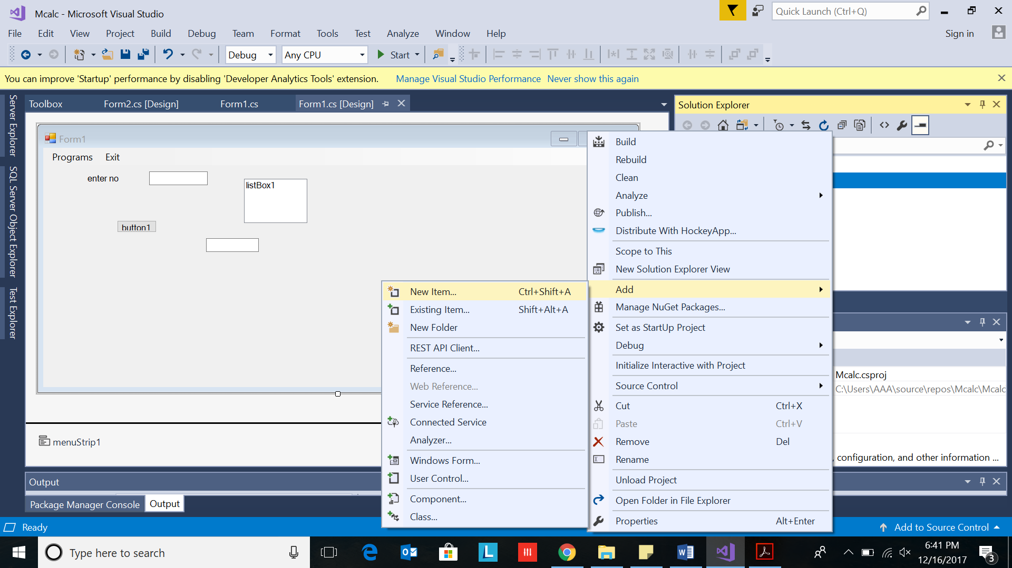

Select NewItem -> Windows Form.

Form Name as Form3

Click Add button

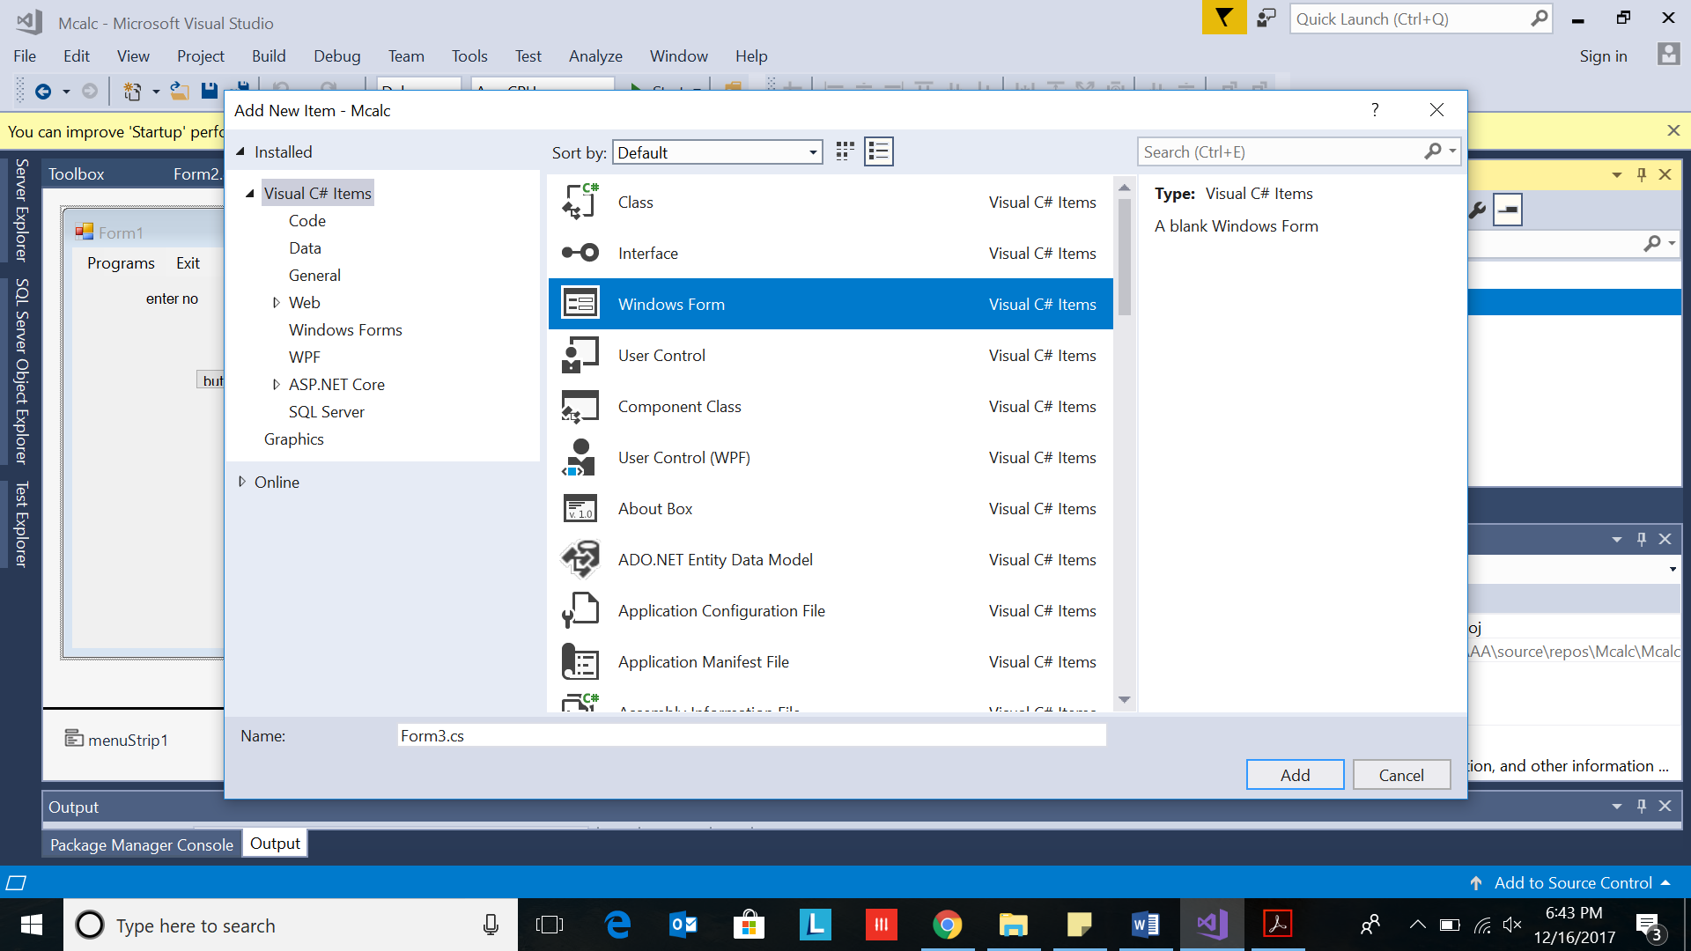

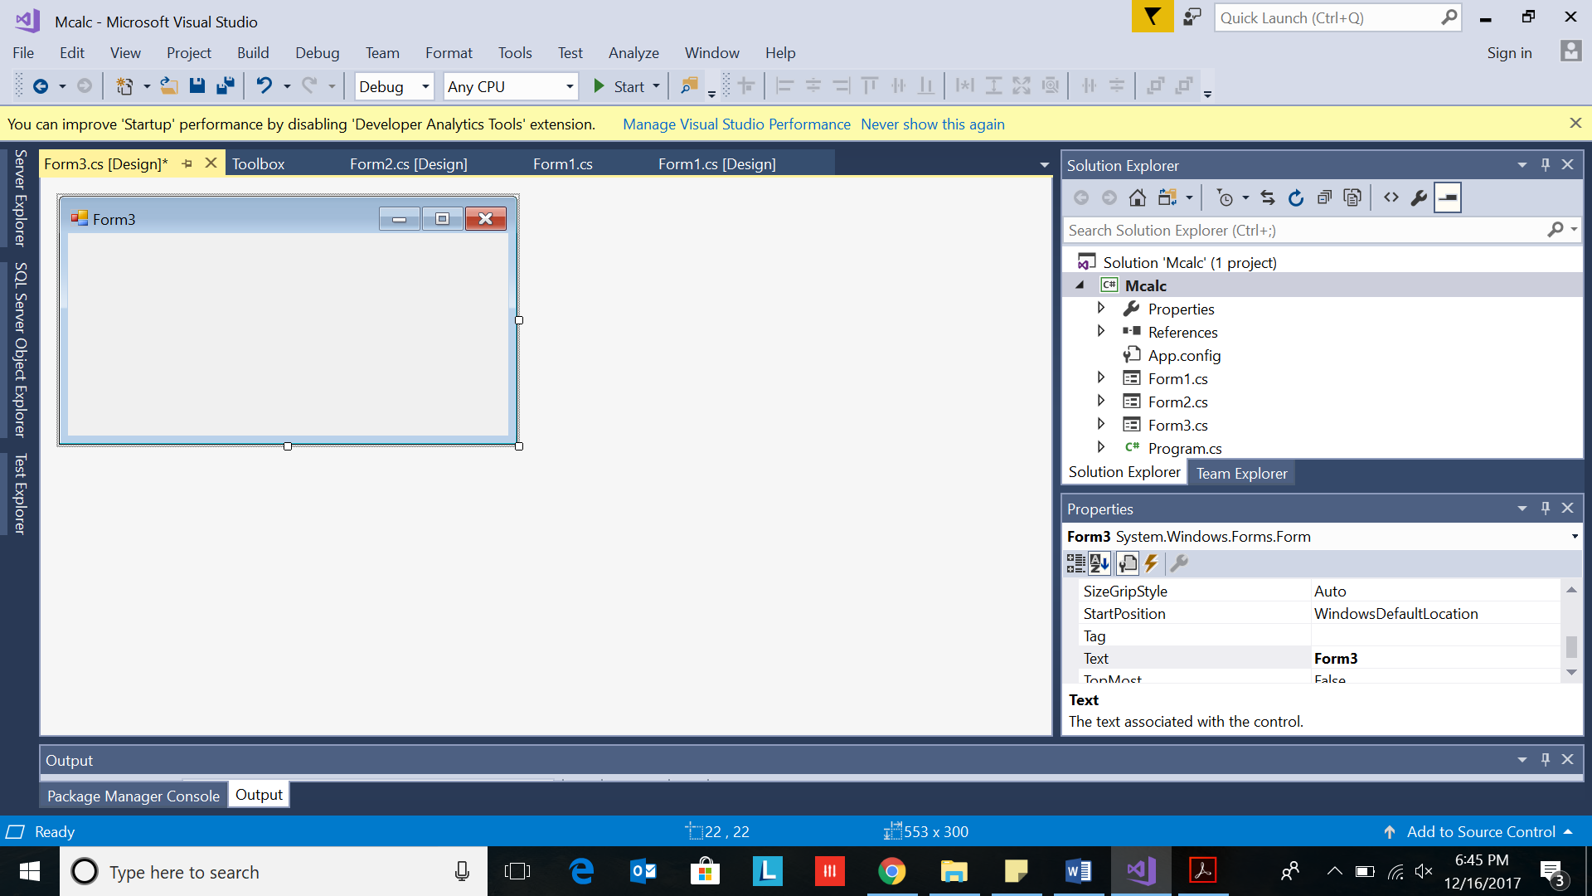

# IV Create Menu

1. Select Toolbox-> Menus&Toolbars->Menustrip

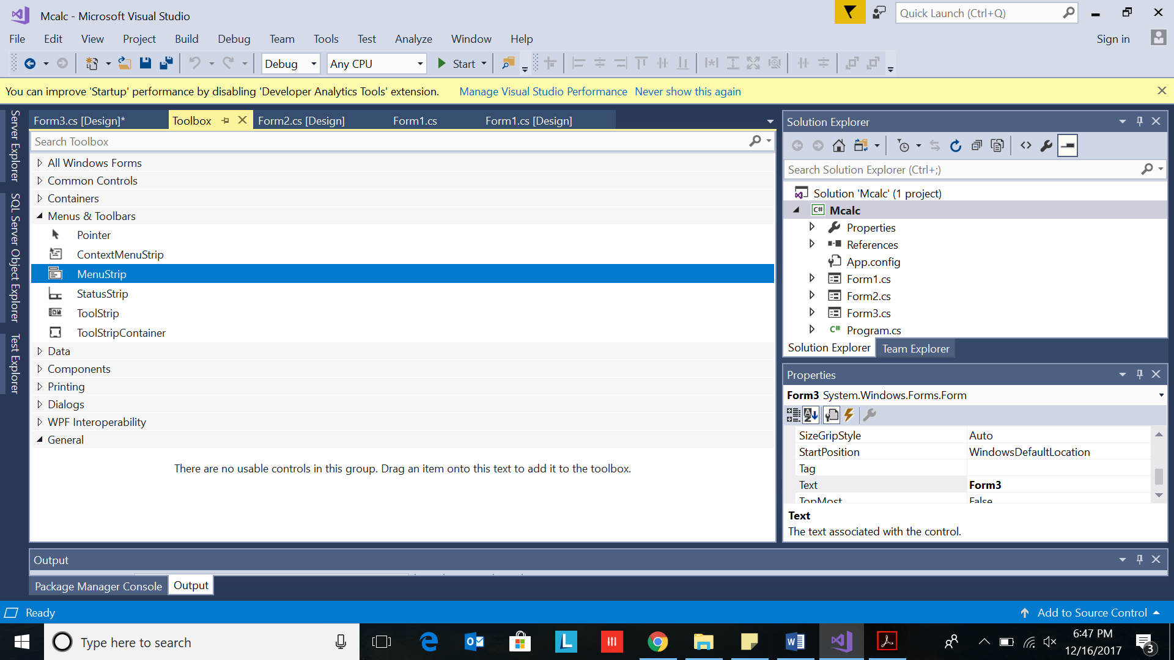

1. Drag and drop on Form1

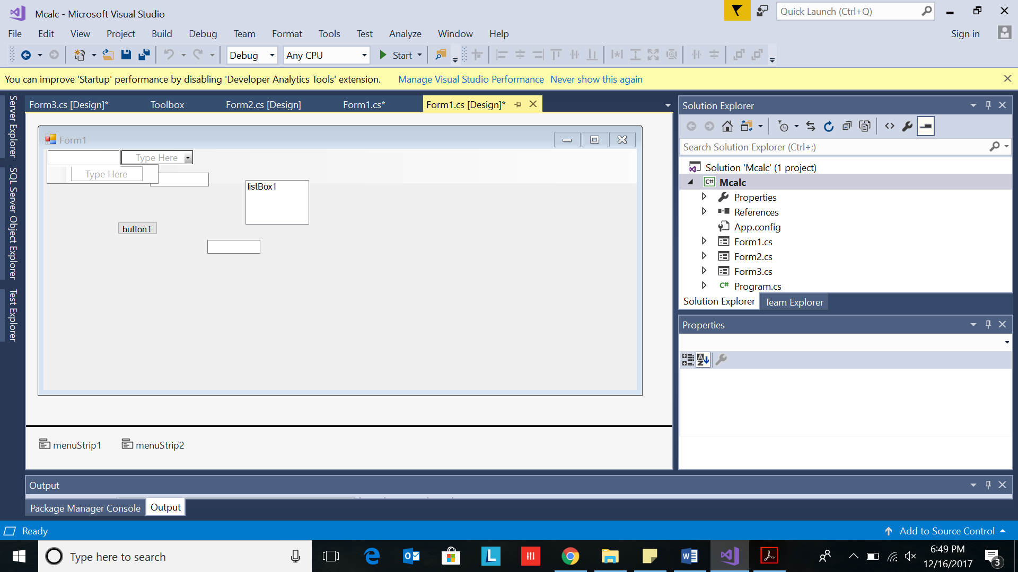

1. Type Programs first.

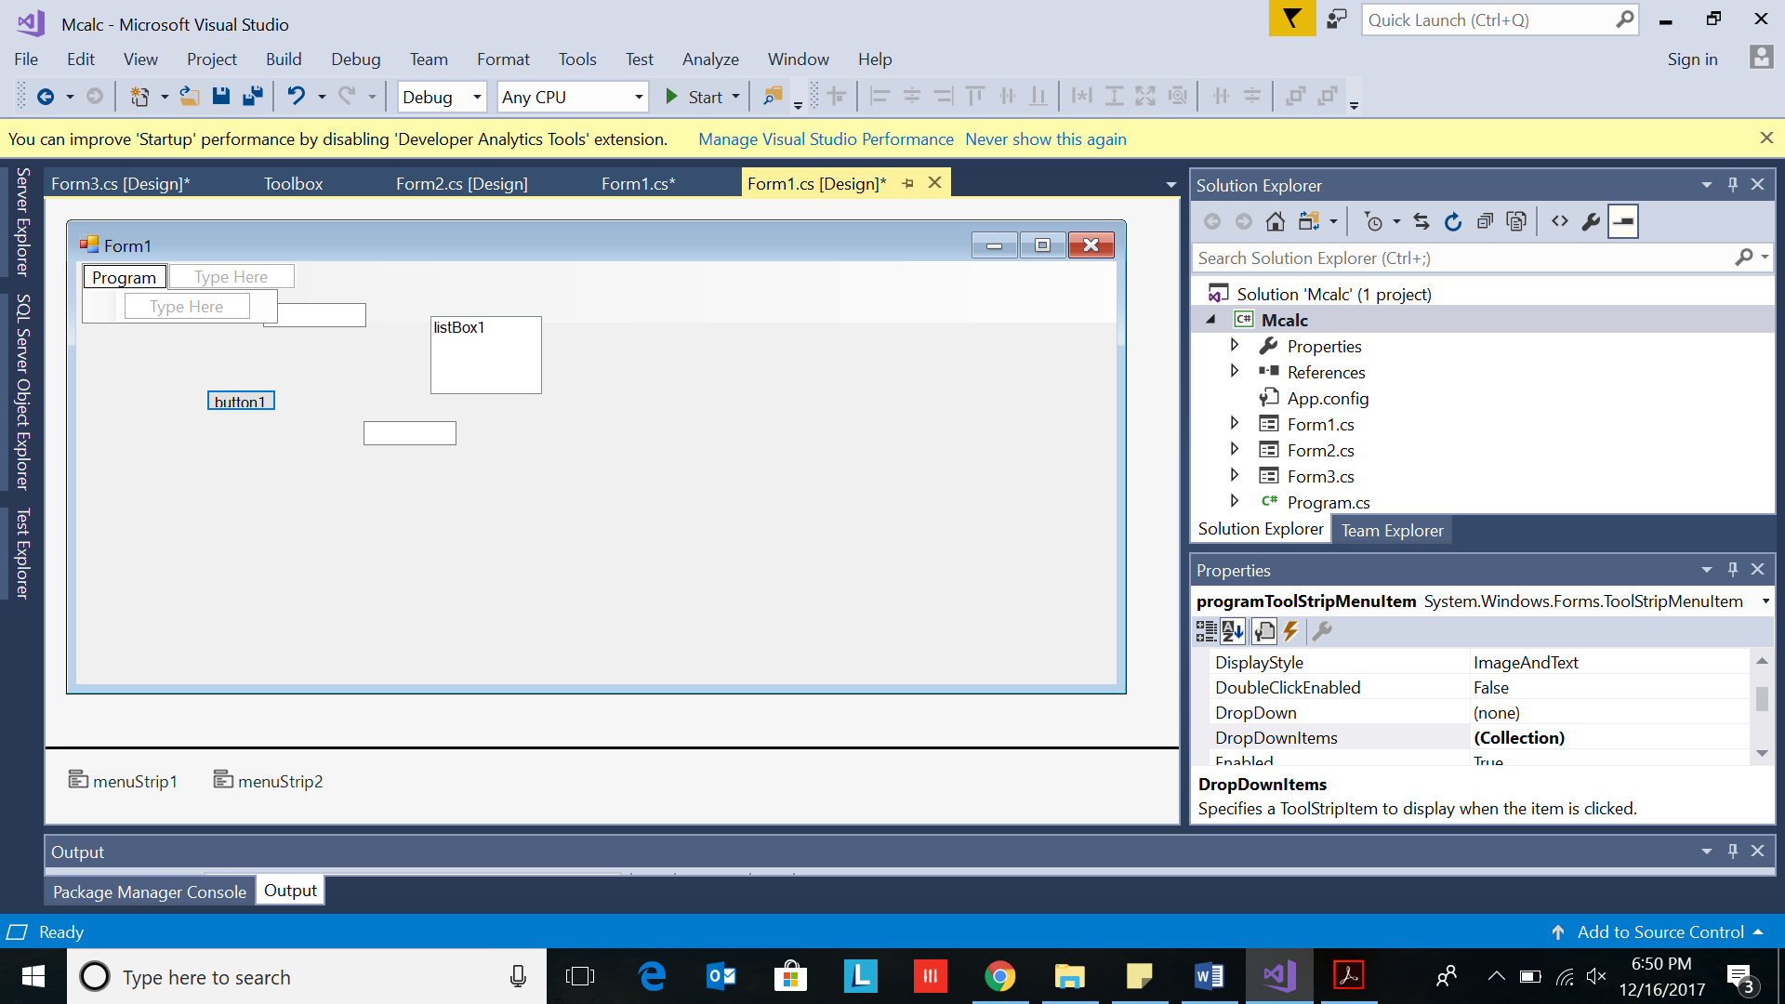

1. Type one below the other:

* Multiplication Table
* EvenOdd
* Factorial

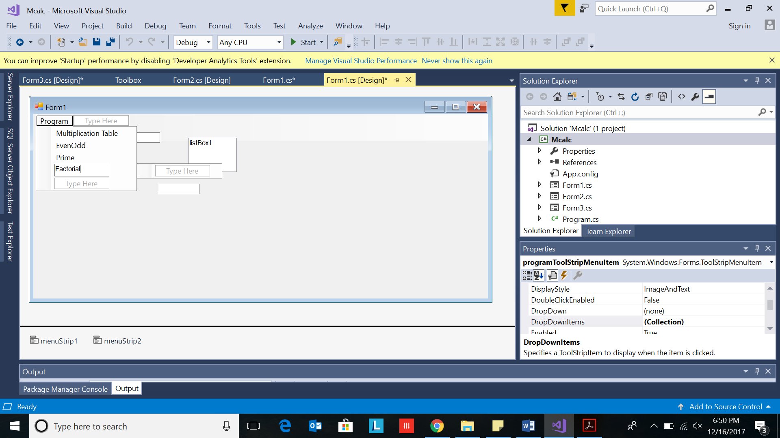

1. Type Exit on side space

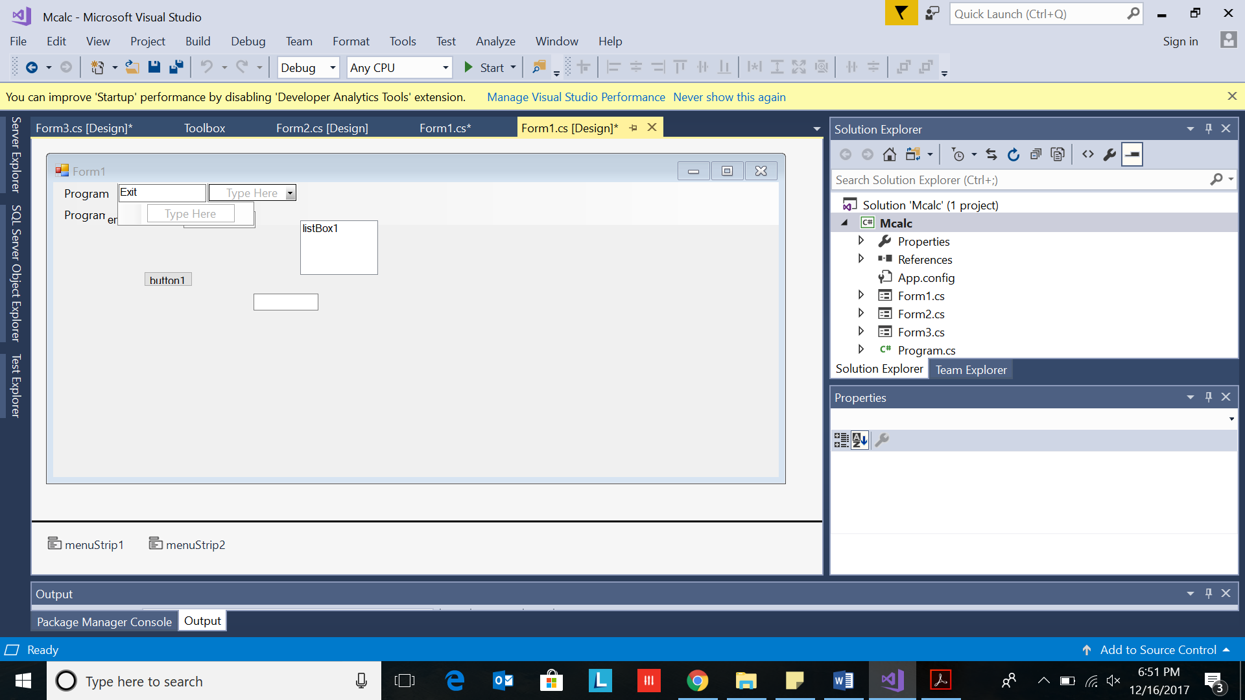

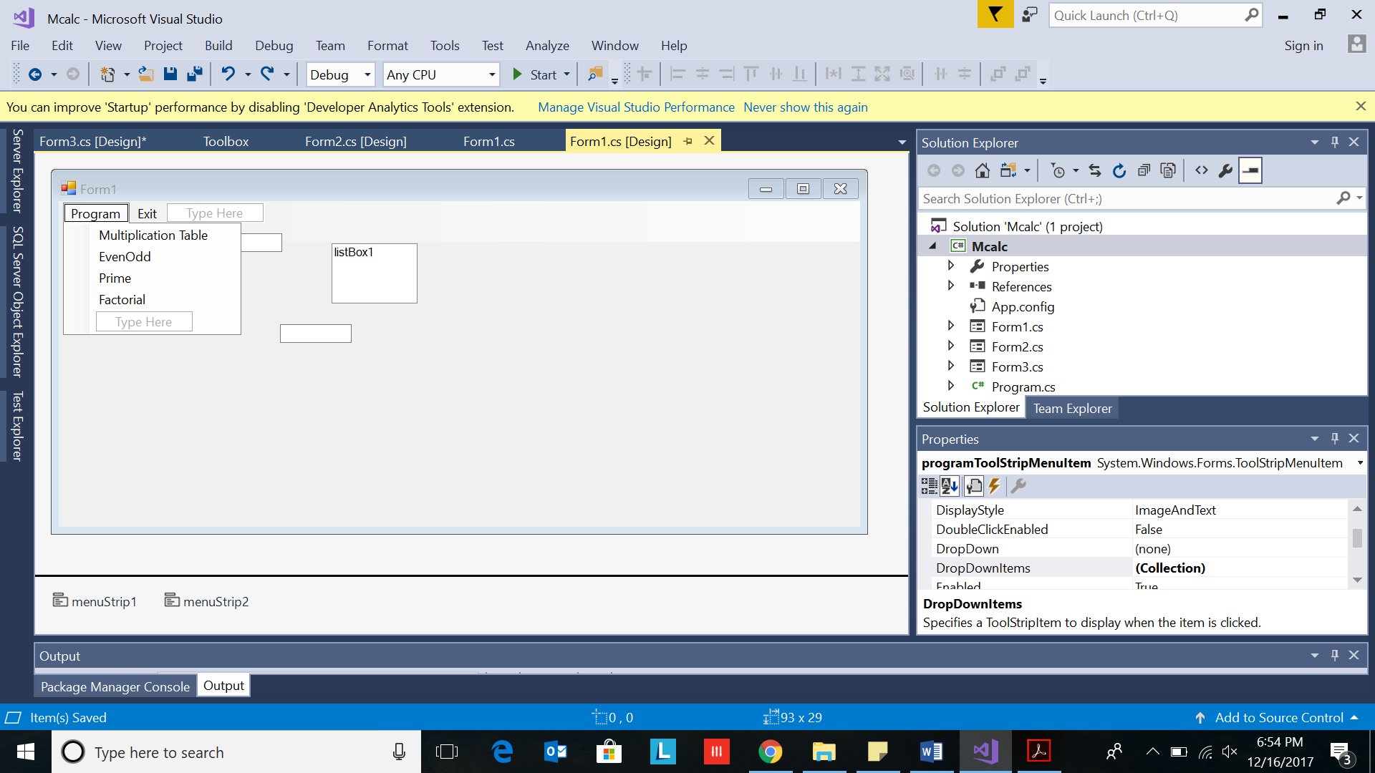

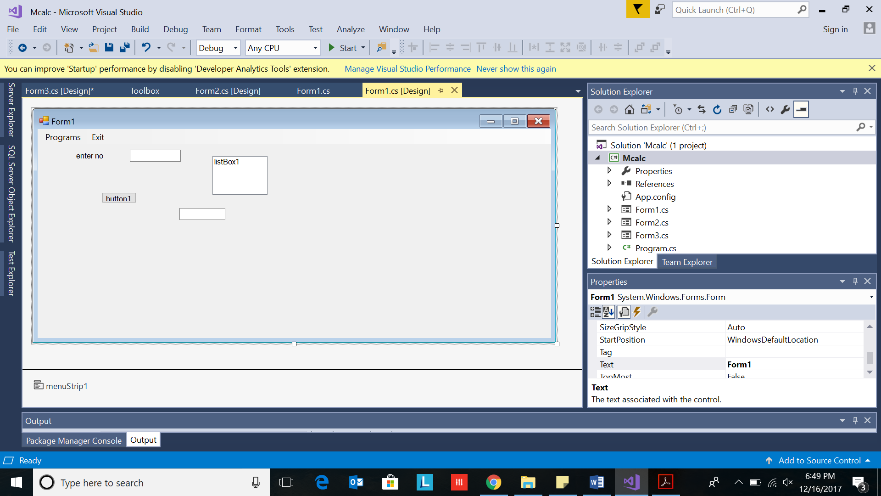

1. Double click on Multiplication table menu

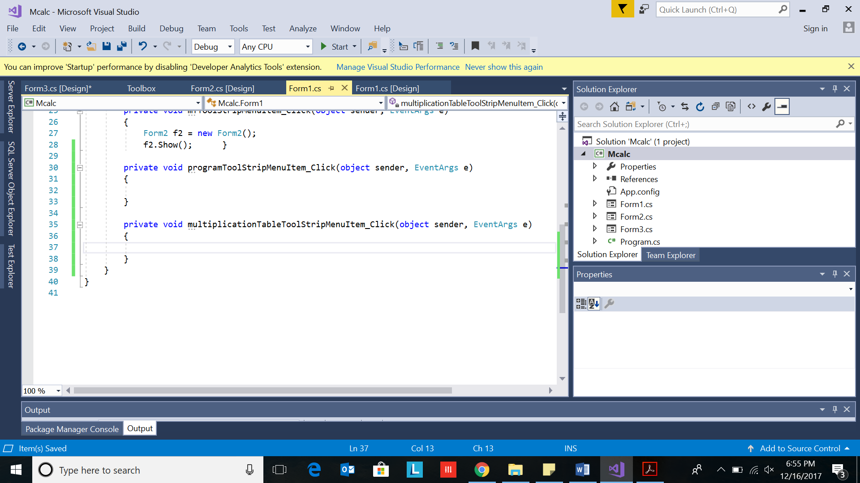

private void multiplicationTableToolStripMenuItem_Click(object sender, EventArgs e)

{

}

1. Type code in yellow. You need to have another form in your application:Form3

private void multiplicationTableToolStripMenuItem_Click(object sender, EventArgs e)

{

Form3 f3 = new Form3();

f3.Show();

}

1. Save
2. Click on Start

Click on form. Alt Printscreen(to copy) and paste in word.

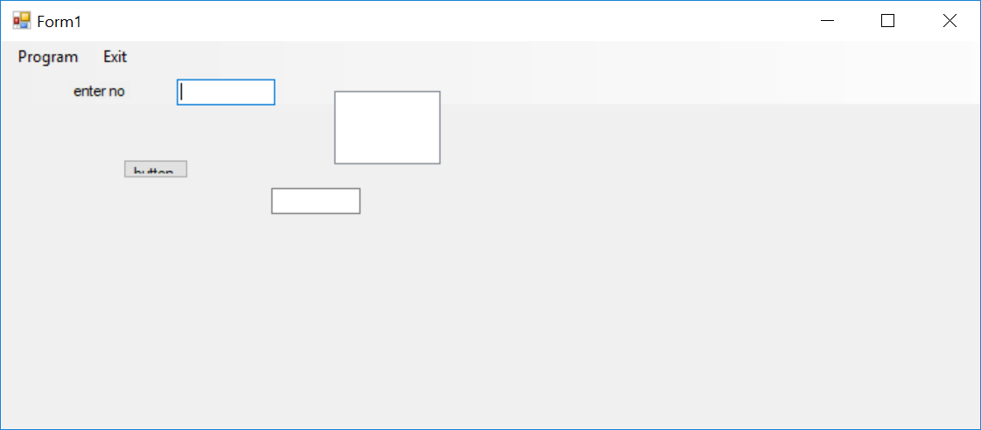

1. Click on Programs. Drop down appears.
2. Click on Multiplication Table option.

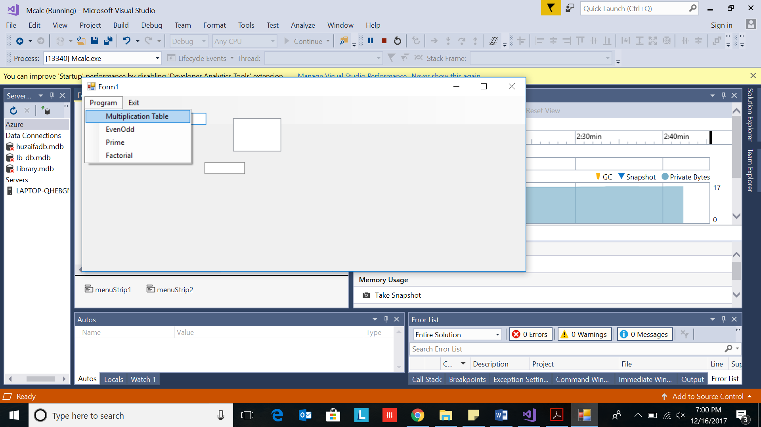

Form3 appears

